South China University of Technology
《Computer Organization and Architecture》Experiment Report
Experiment Title： Sequential System
Name： 谭演锋 Student ID： 202130100456
Class： 计算机全英联合班 Group： None
Collaborator： None
Teacher： 毛爱华
Description
【Objective and Requirement】
Objective
(1) Understand the concept of “state machine”, master how to describe the sequential system based on the idea of “state machine”.
(2) Know the organization structure and design method of sequential system

Requirement
Design a sequential system based on the theory of “state machine”. Make the traffic light on following this rule: “green->yellow->red->green…”. The lightening duration time can be independently set by dial switch. Green and red lights are in continuous light mode, while yellow lights are in flicker mode.

【Environment】
Operating System：Windows XP
Content
【Procedure】
- Step：
Start simulation, manually press “Start” button, make the traffic lights run as the workflow showing below.
When running, manipulate the DSWx switches to set the new initial values. Observe if the traffic lights are interfered? Answer when the change will take effect.
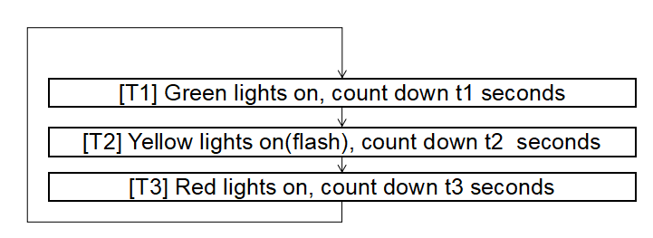
- Data：
Red light | 16 seconds
Yellow light | 3 seconds
Green light | 4 seconds

- Major Procedure：
Start simulation, manually press “Start” button, make the traffic lights run as the workflow showing below.
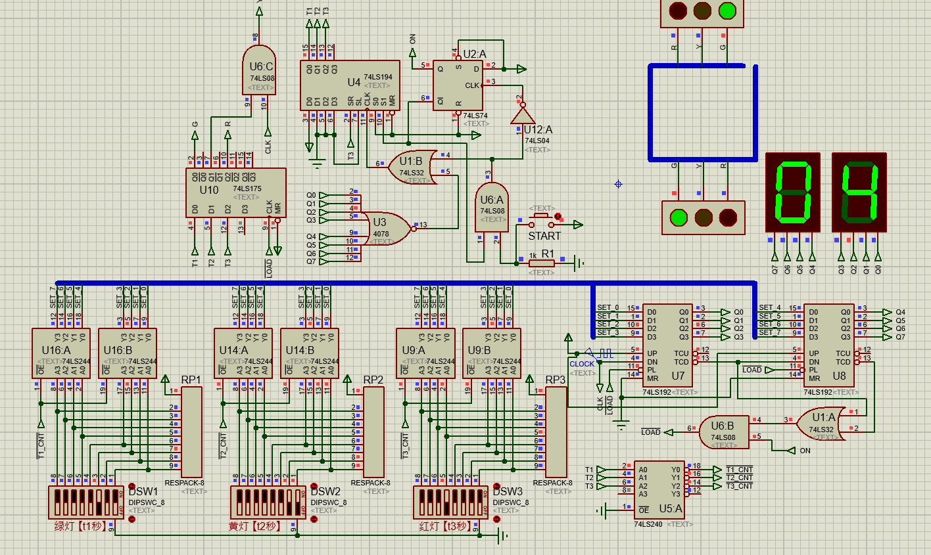
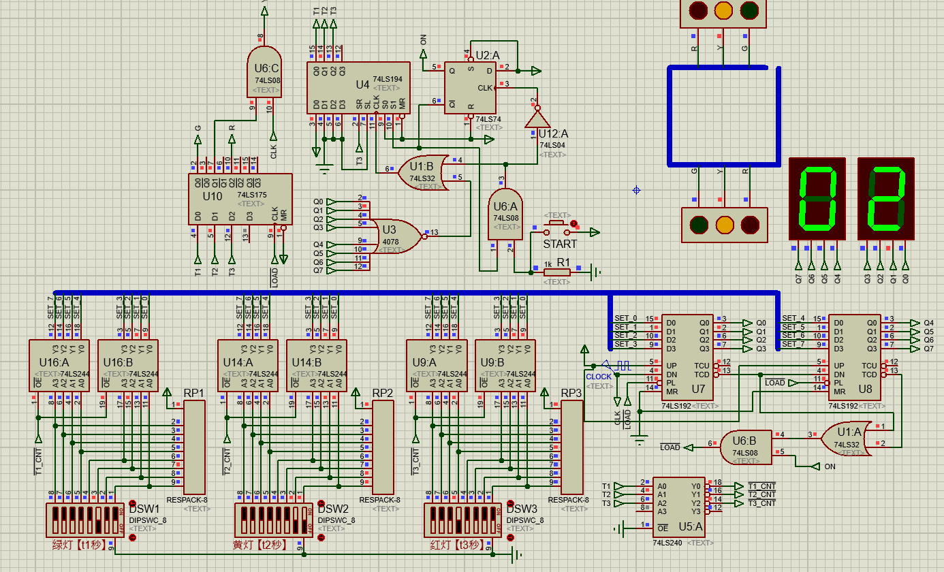
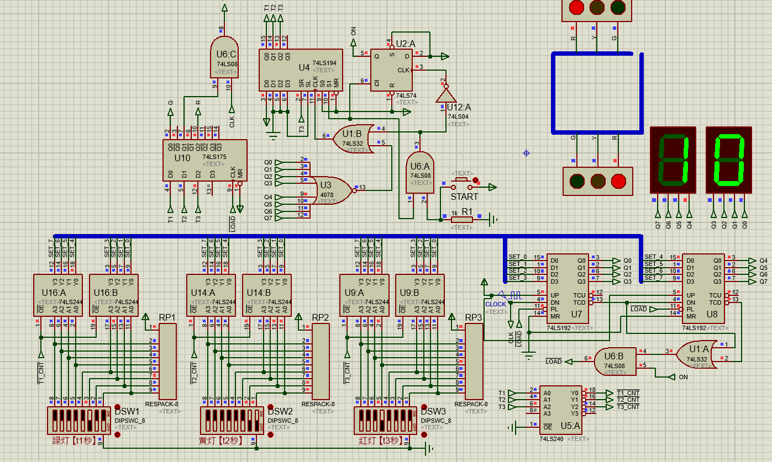
Explanation: By using the switcher we set the green light flashes for 4 second, yellow light flashes 3 seconds, red light flashes 16 seconds.
Set the duration time of light.
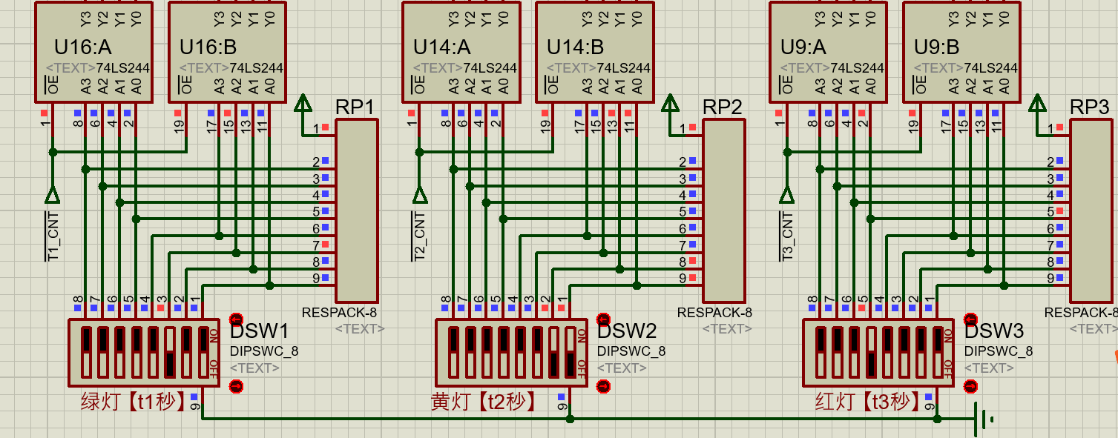
Before CLK enables it, 74LS194 get initial status such as the outputs will be {T1,T2,T3}={1,0,0}, then switch to rotating right shift mode. So the first flash light is green, the yellow and finally red.
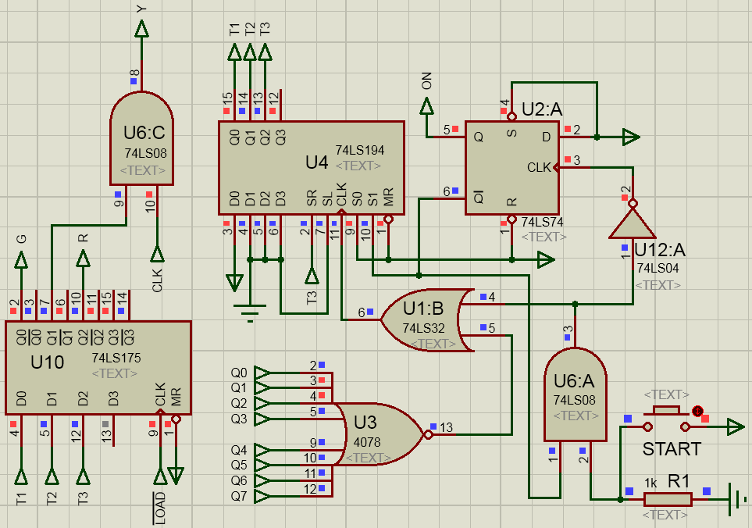
The U5 will enable the 74LS244 output the running time to the BUS SET_x. Then use the 74LS192 run operation that minus the time to run the signal by time and control the lights by Qx.
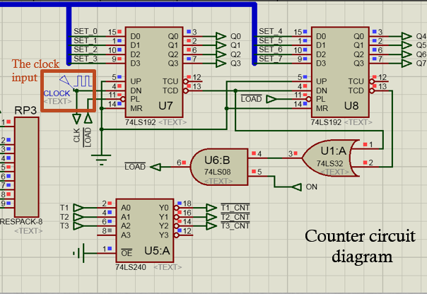
When running, manipulate the DSWx switches to set the new initial values. Observe if the traffic lights are interfered? Answer when the change will take effect

Yes, he traffic lights are interfered. The initial value will change imedialetly as the value is changed by manipulate the DSWx switches to set the new initial values. We can see the figure as followed.
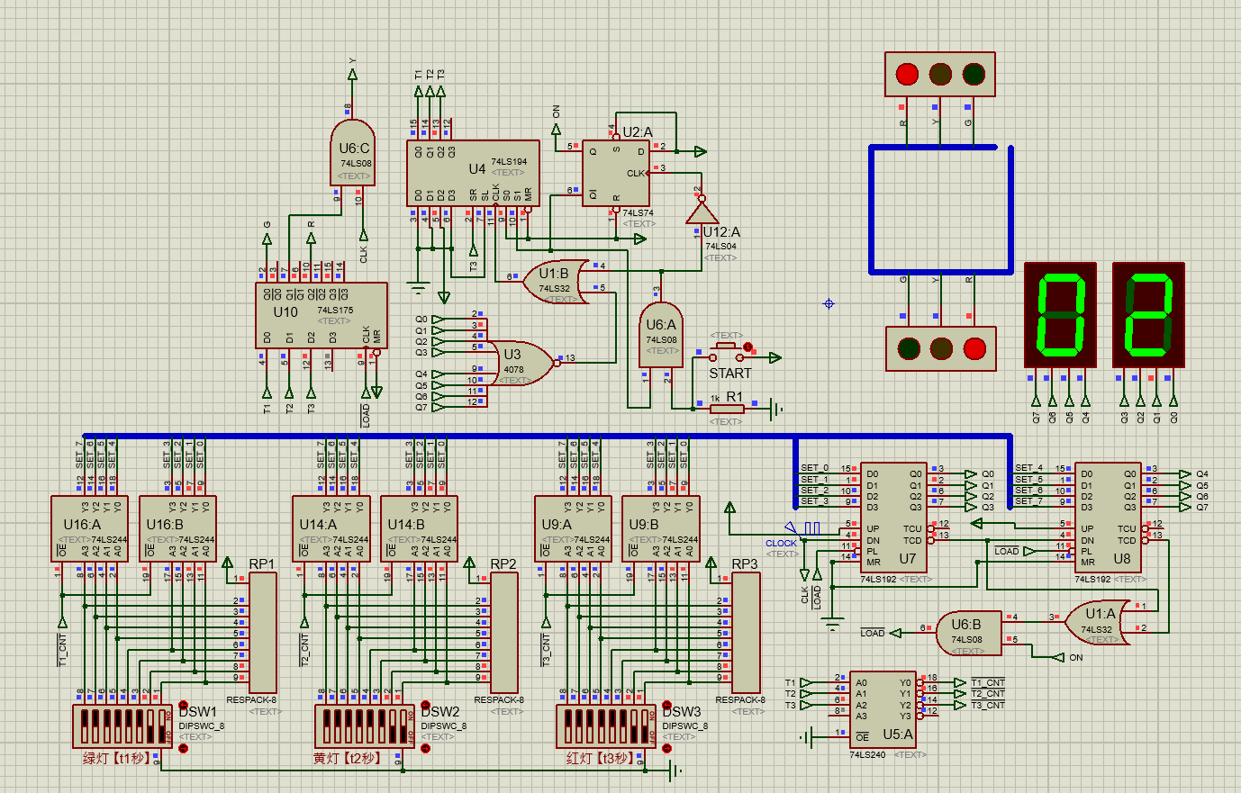
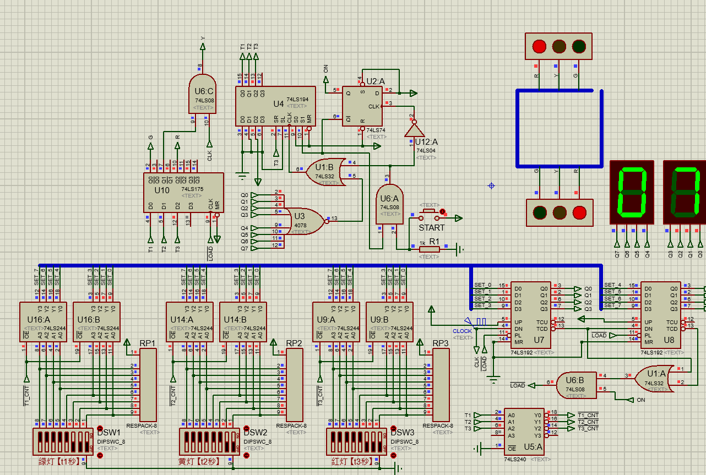
- Bonus question
If I want the red light to be on when pressing the start button, How to modify this circuit?
Method1:

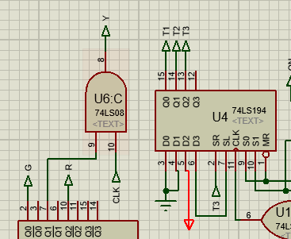

Ground T1 and T2, power T3 which initialize the shift register 74LS194 with a initial state that the output will be {T1,T2,T3}={0,0,1}. And then the 74LS194 should shift right. The next state is 100 which represent the green light. The above functions can also be achieved.

Method2:
Change the position of T1, T2, T3. Let SR become T2.
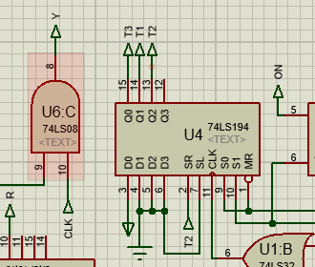

We should change the {T1,T2,T3}={0,0,1} to{1,0,0},then{0,1,0}. If we change like the above, the first state {T1,T2,T3}={0,0,1}. Then shift right the {T1,T2,T3}={0,1,0}. Finally T2(SR) is 1 when the yellow light is on, and the next T3 is 1 after the shift right since the SR=1. So finally we get a cycle.

Conclusion
After finishing the experiment, I have learned the concept of “state machine” which is used to describe the state of the traffic light. And by connecting the circuit I have learned how to construct the state machine by the 74LS192. I also learn how to make use of the shift register to construct the sequential system of the state for selecting a lighted light at on time. Also I have learned how to combine two above part and other auxiliary part of the diagram like selecting running time by swicher to make a traffic light and chang the circuit for constructing the traffic light statrtig from the red light instead of the green light.
Teacher’s Comments and Score
Comment：

Score： Signature：
Date：

